Proposed journal: Eurosurveillance
Type: Rapid communication: around 1,200 words, and have a minimum of eight and up to about 20 references and four illustrations (figures or tables). The abstract should not exceed 80 words.

Title: Antigenic changes in influenza A(H3N2) driven by genetic evolution: Insights from EU/EEA virological surveillance, EU/EEA, week 40, 2023 – week 9, 2024

Short title: Genetic and antigenic diversification of influenza A(H3N2), EU/EEA, 2023-2024
Keywords: influenza, surveillance, Europe, genetic

Authors
Eeva K. Broberg¹, Maja Vukovikj¹, Olov Svartström¹, Iris Hasibra², Maximilian Riess¹ and Angeliki Melidou¹, Members of the ERLI-Net network³ that contributed virus detection and/or characterisation data or were involved in weekly surveillance activities.

Affiliations
¹European Centre for Disease Prevention and Control (ECDC), Stockholm, Sweden
²World Health Organization (WHO) Regional Office for Europe, Copenhagen, Denmark
³Members of the ERLI-Net that contributed virus detection and/or characterisation data or were involved in weekly surveillance activities are listed under collaborators; see list in the end of article.

Abstract, max 80 words
During 2023-24 influenza season in EU/EEA, there was co-circulation of A(H1N1)pdm09, A(H3N2) and B/Victoria viruses. The genetic diversification of these viruses continued and clade 5a.2a.1 of A(H1N1)pdm09, 2a.3a.1 of A(H3N2) and V1A.3a.2 of B/Victoria-lineage viruses dominated. 23% of A(H3N2) 2a.3a.1 viruses were antigenically distinct from current vaccine virus. B/Yamagata-lineage was not detected. The WHO's vaccine recommendations for the 2024-25 season in the northern hemisphere were updated to include a new A(H3N2) component, while maintaining the current A(H1N1)pdm09 and B/Victoria-lineage components.

Seasonal influenza viruses evolve constantly both genetically and antigenically and influenza vaccine components need to be evaluated regularly. Therefore, continuous virological surveillance of influenza virus strains is necessary. This report summarises influenza virological surveillance data in the European Union and Economic Area, for weeks 40/2023 through 9/2024, as reported by national influenza reference laboratories to The European Surveillance System (TESSy) hosted at the European Centre for Disease Prevention and Control (ECDC) and discusses the results in context of the WHO vaccine composition recommendation for northern hemisphere (NH) 2024-25 influenza season.
The data sources and methods were as described earlier [1] .
Detections
In the EU/EEA, within the reporting period, 154718 influenza virus detections (sentinel and non-sentinel combined), were reported from 29 countries of which 97% (150692) were type A and 3% (4026) were type B virus (Table 1, Figure 1).
Of the subtyped influenza A viruses, 30463 (75%) were influenza A(H1)pdm09 and 10174 (25%) were influenza A(H3). Of the 4026 reported influenza type B viruses, the lineage for 809 (20%) was determined, with all viruses falling into the B/Victoria/2/87-lineage. No B/Yamagata/16/88-lineage virus was reported (Table 1, Figure 1).
Genetic characterisation
Within the reporting period, 2567 (2% of all surveillance source detections; 6% of sentinel source detections) viruses from 15 countries were reported with sequence identifier, out of which 2544 sequences could be retrieved and included in the phylogenetic analysis. The 1083 (60%) of the 1815 A(H1N1)pdm09 viruses fell in clade 5a.2a, while 732 (40%) belonged to clade 5a.2a.1 where 710 (97%) to C.1.1.1 subclade defined by T216A and represented by A/Victoria/4897/2022, the virus component for 2023-24 NH egg-based vaccine (Table 1, Supplemental Figure 1). Genetically, 728 (67%) of 5a.2a viruses fell into a subgroup with T120A and additionally K169Q or V47I (within subclade C.1). In 5a.2a.1 viruses, 317 (43%) carried R113K (within C.1.1.1) with or without S85P and 243 (33%) R45K (within C.1.1.1).
All 639 A(H3N2) viruses fell into clade 2a.3, a subclade of 2a represented by A/Darwin/9/2021, the recommended vaccine strain for egg-based vaccines for 2023-24 NH influenza season (Figure 2). Within 2a.3, 98% (n=628) were clade 2a.3a.1, represented by A/Thailand/8/2022 which has been recommended for NH 2024-25 vaccine. Most (n=346, 55%) of A(H3N2) in 2a.3a.1 belonged to J.2 subclade defined by the amino acid substitutions N122D (potential loss of glycosylation site, antigenic site A) and K276E (in antigenic site C). Within 2a.3a.1, also smaller subclade J.1 with I25V (n=212, 33%) was present. (Table 1, Figure 2)
All 90 B/Victoria viruses belonged to clade V1A.3a.2, represented by B/Austria/1359417/2021, the recommended vaccine virus strain for the 2023-24 NH influenza season (Table 1, Supplemental Figure 2). However, 32% (n=29) of the viruses fell in a branch with an E128G substitution.
Antigenic characterisation
Antigenic characterisation data from eight countries were available for 675 viruses (Table 1). Of the 512 characterised A(H1)pdm09 viruses the majority (262, 51%) were A/Sydney/5/2021-like, 248 (48%) were similar to the vaccine virus A/Victoria/4897/2022-like virus, and two were reported as A/Wisconsin/67/2022-like viruses. The majority of the 103 antigenically characterised A(H3) viruses (76, 74%) were reported as A/Darwin/9/2021-like, 24 (23%) as A/Thailand/8/2022-like, and three were not attributed to any of the reporting categories.
Among 60 antigenically characterised influenza B/Victoria viruses, the majority (58, 97%) were similar to the vaccine virus for the 2023/24 NH influenza season (B/Austria/1359417/2021). Two (3%) B/Victoria viruses were not attributed to any of the reporting categories. (Table 1)
Antiviral susceptibility
Since the beginning of the season, 2003 viruses were assessed for antiviral susceptibility to oseltamivir and zanamivir (87% by genomic analysis and 13% by phenotypic analysis) and 1553 viruses to baloxavir marboxil (all by genomic analyses) from in total 14 EU/EEA countries (Table 2). In total, five viruses with reduced or highly reduced inhibition or susceptibility were detected based on genetic analyses: three A(H1)pdm09 viruses carried genetic markers associated with either reduced (NA:I223T) or highly reduced inhibition (NA:H275Y) by oseltamivir; two A(H3) viruses carried amino acid substitutions associated with reduced susceptibility to baloxavir (PA:L28P) (Table 2). For polymerase acidic protein associated to reduced inhibition genotypic susceptibility assessment was performed based on WHO table [2].

Conclusions and discussion

Based on our dataset, this influenza season was characterised by co-circulation of influenza A(H1N1)pdm09, A(H3N2) subtypes and B/Victoria-lineage viruses, with A(H1N1)pdm09 being the predominant virus overall in EU/EEA.
Regarding the antigenic similarity of circulating A(H1N1)pdm09 viruses to the 2023-24 NH vaccine component (A/Victoria/4897/2022-like clade 5a.2a.1 virus (egg-based)), the circulating viruses appeared to be overall antigenically similar. The early European vaccine effectiveness results showed 53% (95% CI: 41 to 63) protection against influenza in all ages in the primary care [3]. Some genetic diversification was observed in the 5a.2a viruses with branches having defined amino acid substitutions with a significant number of viruses such as T120A with K169Q or V47I in 5a.2a and S85P/R113K and R45K in 5a.2a.1. Despite the genetic heterogeneity of recently circulating A(H1)pdm09 viruses, the WHO recommended to maintain the same A(H1)pdm09 component for the 2024/25 influenza season as previous season, based on human serology study results confirming that the NH 2023/24 vaccine post-vaccination serum titres were not significantly reduced for most circulating viruses [4]. Lower VE was, however, observed in the European study against clade 5a.2a.1 viruses (39%, 95% CI: -44 to 74) compared to clade 5a.2a viruses (52%, 95% CI: -7 to 78) [3]; this is also supported by the Canadian Sentinel Practitioner Surveillance Network VE studies (56% vs 67%) [5]. Reduced inhibition by oseltamivir was detected in only three A(H1)pdm09 viruses with the large majority of tested viruses remaining susceptible.
For A(H3N2), almost all circulating viruses fell genetically in clade 2a.3a.1 represented by A/Thailand/8/2022, which was recently recommended as the vaccine component for NH influenza season 2024-25 [4]. It was shown by human serology studies using post-vaccination human sera, that reduced reactivity was seen against some recent viruses expressing HA genes from subclade 2a.3a.1 [4]. Noteworthy, in EU/EEA, the majority (346, 54%), of A(H3N2) viruses belonged genetically to this divergent clade 2a.3a.1 with additional amino acid substitutions in antigenic sites at N122D and K276E (J.2) and another subgroup with I25V (J.1). Early European vaccine effectiveness results in primary care for all ages indeed showed reduced protection of 30% (95% CI: −3 to 54) by the influenza vaccine from the circulating A(H3N2) viruses and in hospital studies 14% (95% CI: −32 to 43). This indicated that many of the currently circulating 2a.3a.1 subclade strains in the EU/EEA had diversified antigenically from the NH 2023-24 vaccine virus A/Darwin/9/2021 [4]. In our EU/EEA data, only 23% of antigenically characterised viruses were A/Thailand/8/2022-like which would indicate that they were less well recognised by the vaccine virus A/Darwin/9/2021 antisera. It needs, however, to be noted that antigenic characterisations were not performed for all circulating 2a.3a.1 viruses and that antigenic characterisation data do not necessarily reflect the proportion of different (sub)clades among circulating viruses. Furthermore, partially differences in the antigenic and/or human serology data in comparison with the VE data could possibly be explained by the fact that in the EU/EEA, as elsewhere, some available vaccines are produced in eggs rather than in cell lines [6-9]. Reduced susceptibility to baloxavir marboxil was reported in only two A(H3) viruses from two different countries with the large majority of tested viruses remaining susceptible.
For the B/Victoria -lineage, all antigenically characterised viruses were V1A.3a.2 B/Austria/1359417/2021-like, which is the current vaccine component in tri- and quadrivalent vaccines in the NH 2023/24. Even if genetic diversification continues within this lineage, the currently circulating viruses in the EU/EEA have been still well covered by the vaccine virus antigenically and no update to the vaccine component was proposed by WHO [4].
There are some additional limitations to these data. The specimen sources (sentinel GPs, hospital, ICU, outbreak investigations) and selection processes for the viruses that undergo characterisation vary from country to country. Only a small percentage (0.4% antigenically and 2% genetically; 3% and 6% of the sentinel source viruses, respectively) of detected viruses were characterised overall. ECDC and WHO Regional Office for Europe have previously recommended to sequence all influenza viruses detected from sentinel sources and we are still far from this target [10].
Despite the challenges in collecting influenza surveillance data collection, the detection and characterization of influenza viruses within the EU/EEA play a vital role in identifying which viruses should be sent to a WHO Collaborating Centre for in-depth analysis. These analyses are essential for guiding the decision-making process during the biannual WHO influenza vaccine composition meetings.

Figures and tables

Table 1. Influenza virus detections in sentinel and non-sentinel source specimens by type and subtype cumulatively for the weeks 40/2023-9/2024
 | Sentinel |  | Non-sentinel
Detections by virus (sub)type | Number | % | Number | %
Influenza A | 12 397 | 96 | 138 295 | 98
A(H1)pdm09 | 8 296 | 81 | 22 167 | 73
A(H3) | 2 136 | 19 | 8 038 | 27
A not subtyped | 1 965 | - | 108 090 | -
Influenza B | 561 | 4 | 3 465 | 2
B/Victoria -lineage | 256 | 100 | 553 | 100
B/Yamagata -lineage | 0 | 0 | 0 | 0
Unknown lineage | 305 | - | 2 912 | -
Total detections  (total tested) | 12 958  (66 596) | 19 | 141 760  (1 168 394) | 12
Antigenic characterisations | Number | %
Influenza A
A(H1)pdm09
5a.2a A/Sydney/5/2021-like³ | 262 | 51.2
5a.2a.1 A/Victoria/4897/2022-like^{4,5} | 248 | 48.4
5a.2a.1 A/Wisconsin/67/2022-like^{4,5} | 2 | 0.4
Subtotal | 512 | 100.0
A(H3)
2a A/Darwin/9/2021-like¹⁻⁴ | 76 | 73.8
2a.3a.1 A/Thailand/8/2022-like⁵ | 24 | 23.3
Not categorised | 3 | 2.9
Subtotal | 103 | 100.0
Influenza B
B/Victoria-lineage
V1A.3a.2 B/Austria/1359417/2021-like¹⁻⁵ | 58 | 96.7
Not categorised | 2 | 3.3
Subtotal | 60 | 100.0
Phylogenetic analysis | Number | %
Influenza A
A(H1)pdm09
5a.2a (C.1) | 1029 | 56.7
5a.2a + T216A (C.1.7) | 54 | 3.0
5a.2a.1 (C.1.1) | 22 | 1.2
5a.2a.1+T216A (C.1.1.1) | 710 | 39.1
Subtotal | 1815 | 100.0
A(H3)
2a.3a (G.1.3.1) | 10 | 1.6
2a.3a.1 (J) | 50 | 7.8
2a.3a.1 + I25V (J.1) | 212 | 33.2
2a.3a.1 + N122D, K276E (J.2) | 346 | 54.1
2a.3a.1 Q173R, K276E (J.4) | 20 | 3.1
2a.3b (G.1.3.2) | 1 | 0.2
Subtotal | 639 | 100.0
Influenza B
B/Victoria-lineage
V1A.3a.2 (C.2) | 1 | 1.1
V1A.3a.2 (C.3) | 2 | 2.2
V1A.3a.2 (C.5) | 9 | 10.0
V1A.3a.2 (C.5.1) | 35 | 38.9
V1A.3a.2 (C.5.6) | 14 | 15.6
V1A.3a.2 + E128G (C.5.7) | 29 | 32.2
Subtotal | 90 | 100.0

1 WHO recommended vaccine virus for the 2022 southern hemisphere influenza season (Trivalent vaccine)
2 WHO recommended vaccine virus for the 2022-2023 northern hemisphere influenza season (Trivalent vaccine)
3 WHO recommended vaccine virus for the 2023 southern hemisphere influenza season (Trivalent vaccine)
4 WHO recommended vaccine virus for the 2023-2024 northern hemisphere influenza season (Trivalent vaccine)
5 WHO recommended vaccine virus for the 2024 southern hemisphere influenza season (Trivalent vaccine)

Table 2. Influenza subtypes and lineages with and without reduced inhibition following antiviral susceptibility testing to oseltamivir reported to TESSy, weeks 40/2023 through 9/2024, EU/EEA. NI: Normal inhibition; NS: Normal susceptibility; HRI: Highly reduced inhibition; RI: Reduced inhibition; RS: Reduced susceptibility; prefix ‘AA’: Amino acid, refers to genotypic testing result.

Oseltamivir susceptibility | NI n (%) | AANI n (%) | AAHRI n (%) | AARI n (%) | Total
Influenza A
A(H1)pdm09 | 185 (13%) | 1239 (87%) | 2 (0.1%)ª | 1 (0.1%)^{b} | 1427
A(H3) | 54 (11%) | 458 (89%) | 0 (0%) | 0 (0%) | 512
Influenza B
B/Victoria lineage | 21 (33%) | 43 (67%) | 0 (0%) | 0 (0%) | 64
Total | 260 (13%) | 1740 (87%) | 2 (0.1%) | 1 (0%) | 2003
Zanamivir susceptibility | NI n (%) | AANI n (%) | AAHRI n (%) | AARI n (%) | Total
Influenza A
A(H1)pdm09 | 185 (13%) | 1242 (87%) | 0 | 0 | 1427
A(H3) | 54 (11%) | 458 (89%) | 0 | 0 | 512
Influenza B
B/Victoria lineage | 21 (33%) | 43 (67%) | 0 | 0 | 64
Total | 260 (13%) | 1743 (87%) | 0 | 0 | 2003
Baloxavir marboxil  susceptibility |  | AANS n (%) | AARS n (%) |  | Total
Influenza A
A(H1)pdm09 |  | 1113 (100%) | 0 (0%) |  | 1113
A(H3) |  | 400 (99.5%) | 2 (0.5%)^{c} |  | 402
Influenza B
B/Victoria lineage |  | 38 (100%) | 0 (0%) |  | 38
Total |  | 1551 (100%) | 2 (0.1%) |  | 1553
ª: These viruses carried mutation NA:H275Y
^{b}: This viruses carried mutation NA:I223T
^{c}: These viruses carried mutation PA:L28P

Figure 1. Number of detections in the A) sentinel and B) surveillance system by subtype and proportion positive of all tested by week, EU/EEA, weeks 40/2023 through 9/2024.

A.

B.

Figure 2. Phylogenetic comparison of influenza A(H3N2) HA genes. The vaccine strains are red, reference strains black and sequences reported to TESSy coloured according to the virus collection date by month (2023: October red, November yellow, December grey; 2024: January green, February, turquoise).
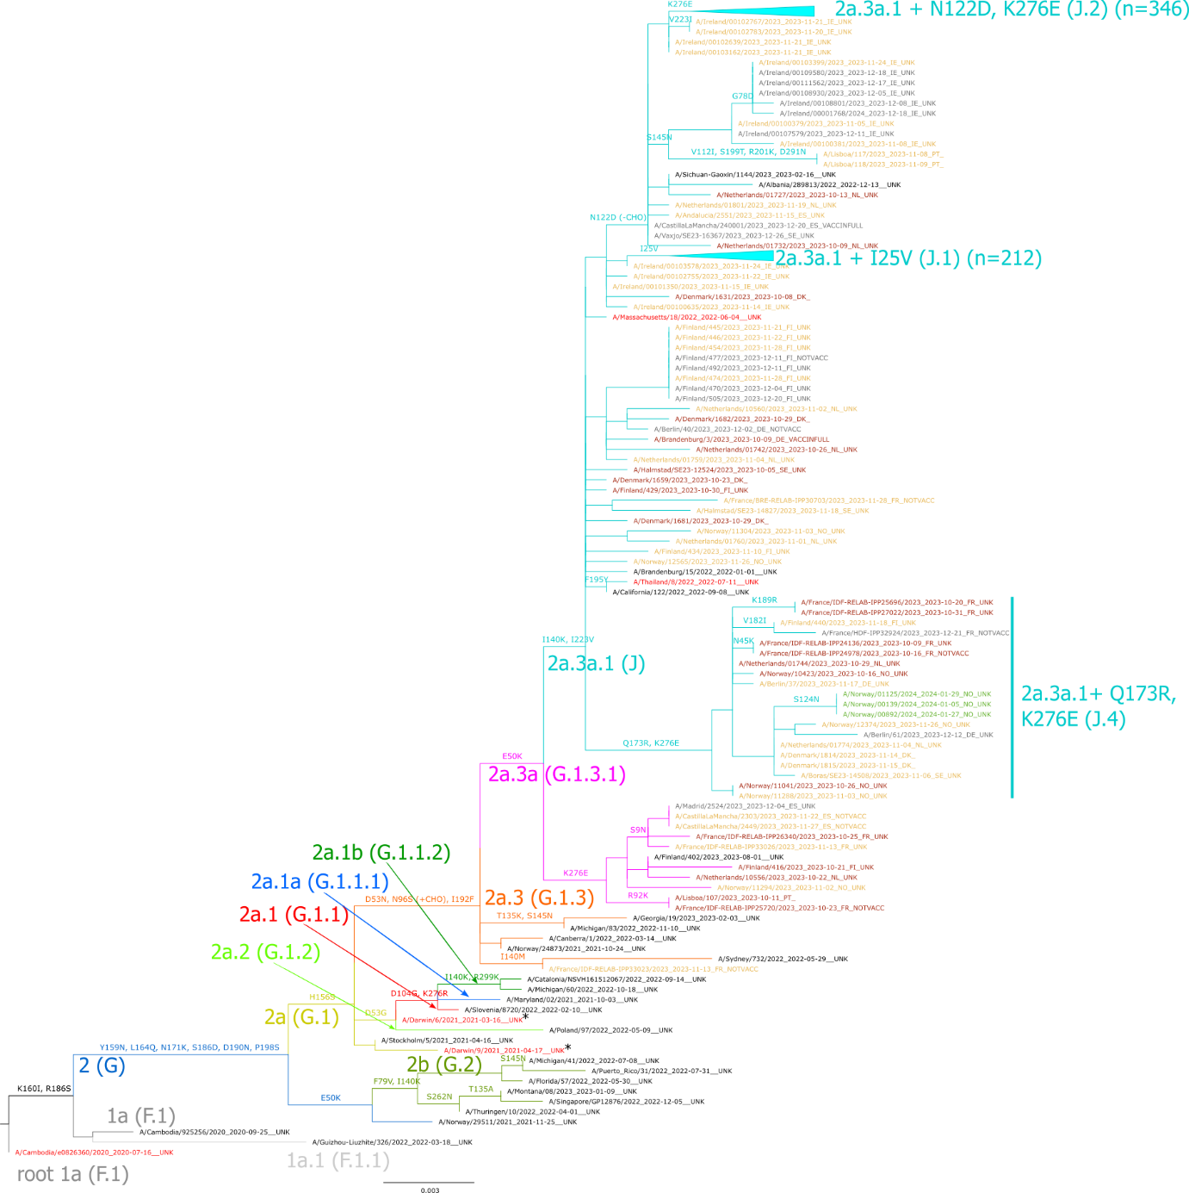

Supplemental materials

Supplemental Figure 1 SF1. Phylogenetic comparison of influenza A(H1N1)pdm09 HA genes. The vaccine strains are red, reference strains black and sequences reported to TESSy coloured according to the virus collection date by month (2023: October red, November yellow, December grey; 2024: January green, February, turquoise).

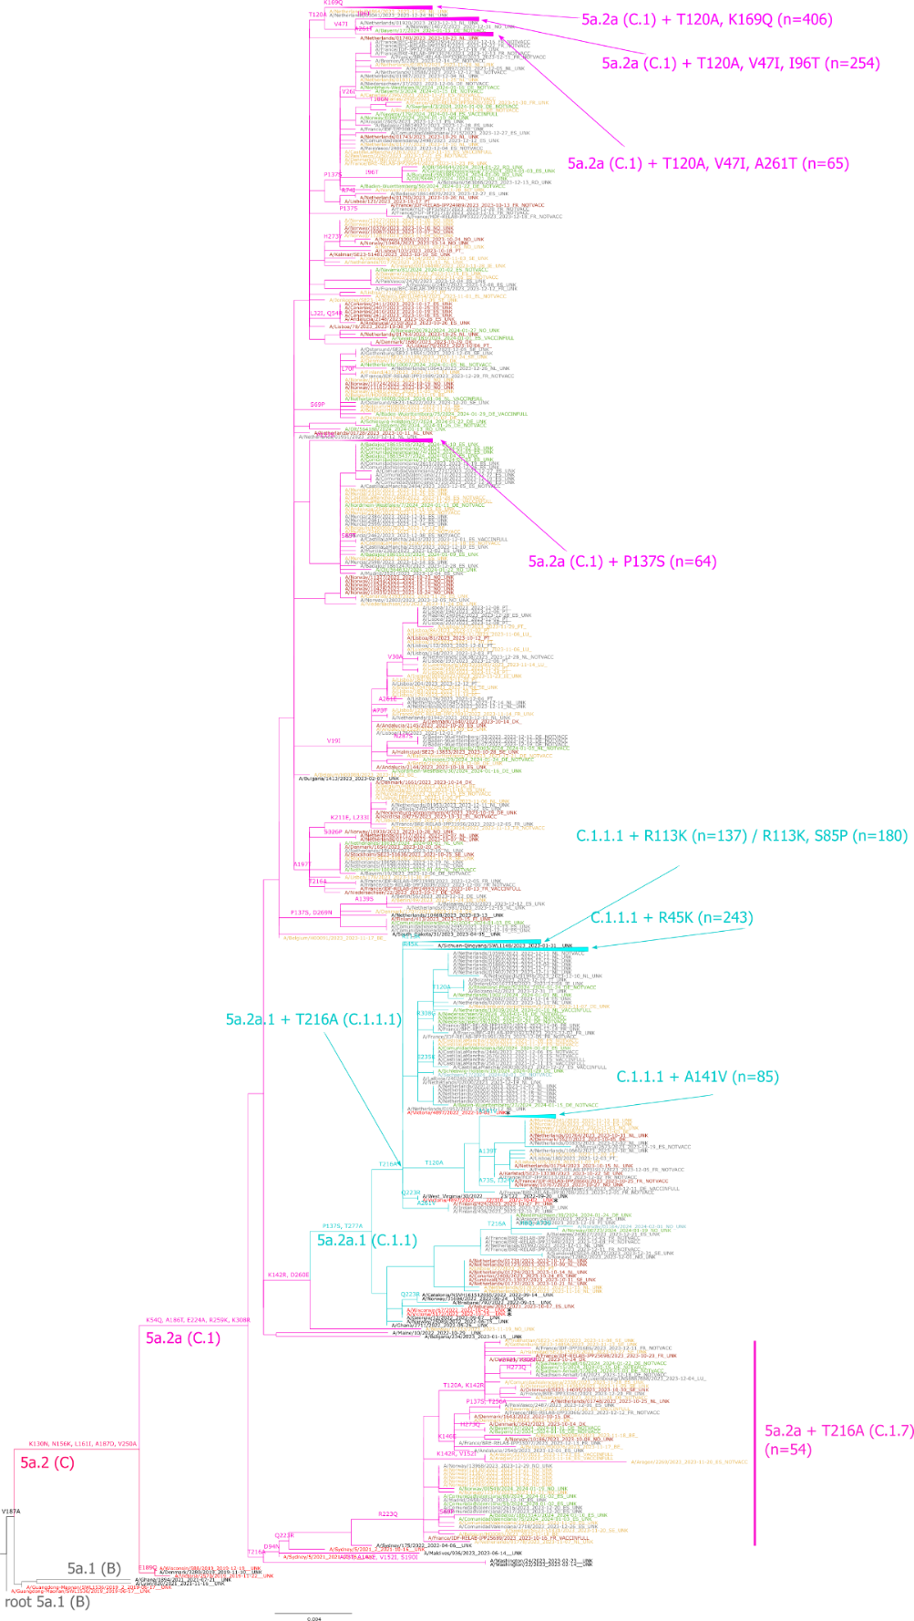

Supplemental Figure 2 SF2. Phylogenetic comparison of influenza B/Victoria-lineage HA genes. The vaccine strains are red, reference strains black and sequences reported to TESSy coloured according to the virus collection date by month (2023: October red, November yellow, December grey; 2024: January green, February, turquoise).
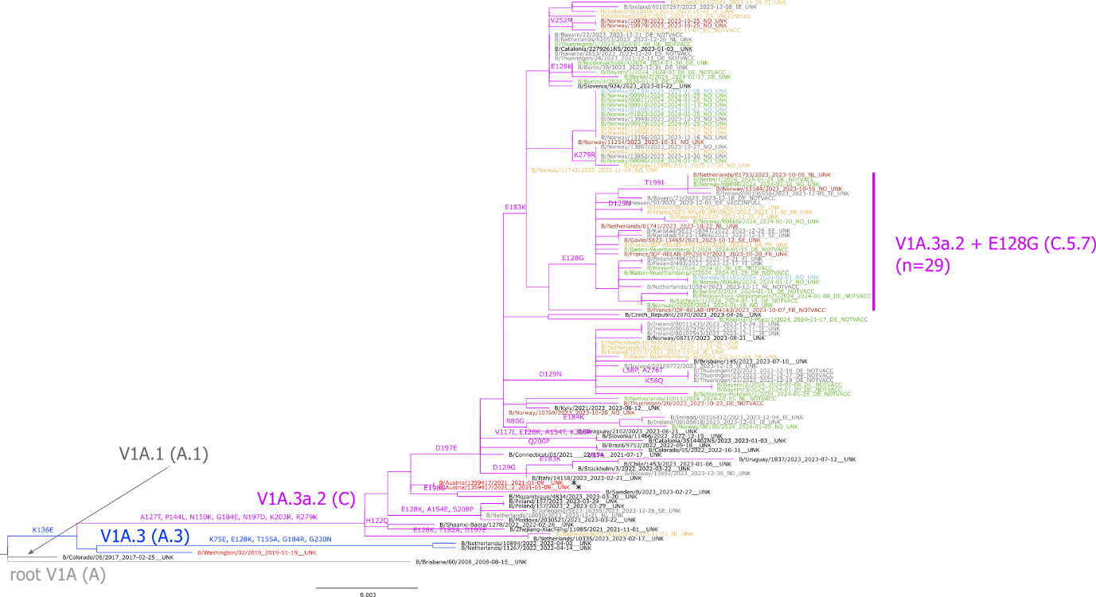

Ethical statement
Ethical approval was not required for this study as Individuals are not identifiable and only virus data are included.

Disclaimer
The authors alone are responsible for the views expressed in this article and they do not necessarily represent the views, decisions or policies of the institutions with which they are affiliated.
The authors affiliated with the World Health Organization (WHO) are alone responsible for the views expressed in this publication and they do not necessarily represent the decisions or policies of the WHO.
Data are publicly available through www.erviss.org and/or upon data access request from ECDC and sequences publicly accessible through GISAID (see acknowledgement).

Conflict of interest
None declared.

Funding statement
ECDC and WHO internal funds were used for the conduction of the study. Generation of the data by national influenza centres and other laboratories is funded by national and other funds.

Collaborators and affiliations
Austria:
Belgium:
Bulgaria:
Croatia:
Czech Republic:
Denmark: Amanda Bolt Botnen and Ramona Trebbien, Statens Serum Institut, Copenhagen
Estonia:
Finland: Niina Ikonen and Erika Lindh, Finnish Institute for Health and Welfare (THL), Helsinki
France: Vincent Enouf, National Reference Center of Respiratory Viruses - Institut Pasteur, Paris, and Laurence Josset, National Reference Center of Respiratory Viruses - Hospices Civils de Lyon, Lyon.
Germany: Ralf Duerrwald and Marianne Wedde, Robert Koch Institute, Berlin
Greece: Maria Exindari, National influenza Centre for N. Greece, Thessaloniki and Emmanouil Mary, Research Staff Scientist, National Reference Laboratory for S. Greece, Hellenic Pasteur Institute, Athens
Hungary:
Iceland:
Ireland: Elaine Brabazon, Health Service Executive, Health Protection Surveillance Centre, Dublin, and Charlene Bennett, National Virus Reference Laboratory, University College Dublin
Italy: Simona Puzelli and Antonino Bella, Institute of Health (Istituto Superiore di Sanità), Rome
Liechtenstein:
Lithuania:
Luxembourg:
Latvia:
Malta:
Netherlands: Ron Fouchier, Erasmus University Medical Center, Rotterdam, and Adam Meijer, Dutch National Institute for Public Health and the Environment (RIVM), Bilthoven
Norway: Andreas Rohringer and Karoline Bragstad , Norwegian Institute of Public Health, Oslo
Poland:
Portugal: Raquel Guiomar, National Reference Laboratory for Influenza and Other Respiratory Viruses, Infectious Diseases Department, and Ana Paula Rodrigues, Department of Epidemiology, National Institute of Health Doctor Ricardo Jorge
Romania: Mihaela Lazar, “Cantacuzino” National Medical-Military Research-Development Institute, Rodica Popescu, National Institute of Public Health Romania.
Slovak Republic:
Slovenia: Nataša Berginc, National Laboratory for Health, Environment and Food, Ljubljana; and Maja Sočan, National Institute of Public Health, Ljubljana,
Spain: Francisco Pozo and Inmaculada Casas, National Centre for Microbiology, Institute of Health Carlos III, Madrid. Consortium for Biomedical Research in Epidemiology and Public Health (CIBERESP).
Sweden: Annasara Carnahan and Neus Latorre-Margalef, Public Health Agency of Sweden, Stockholm
ECDC:
WHO European Region:

Authors’ contributions
EB Conceptualisation, methodology, validation, data curation (lead); writing – original draft (lead); formal analysis (lead); visualisations (lead); writing – review and editing (equal);
MV, IH, MR, OS and AM data curation, analysis, visualisation (equal) – writing – review and editing (equal);
OS phylogenetic analysis and visualisation;
Members of the network coordinated national surveillance activities, collection of specimens and epidemiological data, analysed the specimens and provided data to TESSy and GISAID, reviewed the analysis and approved the final manuscript. All authors contributed to the work, reviewed and approved the manuscript before submission.

Acknowledgements
We express our gratitude to the TESSy data management team, especially Marius Valentin Valcu, for the technical support. We would like to thank Erik Alm (ECDC) for the development of the influenza genetic analysis tool that was used in this study. We would like to acknowledge Edoardo Colzani (ECDC) and XXX (WHO Regional Office for Europe) for reviewing the manuscript and for their valuable comments. We acknowledge all the members of the European region influenza surveillance network for their work on influenza surveillance data collection. We gratefully acknowledge the authors of the HA sequences retrieved from GISAID and used in this study. We would also like to acknowledge the physicians and nurses of sentinel network sites and intensive care units for their contribution in providing respiratory specimens.

Specific country acknowledgements:
Austria:
Belgium:
Bulgaria:
Croatia:
Czech Republic:
Denmark:
Estonia:
Finland:
France:
Germany:
Greece:
Hungary:
Iceland:
Ireland:
Italy:
Liechtenstein:
Lithuania:
Luxembourg:
Latvia:
Malta:
Netherlands:
Norway:
Poland:
Portugal:
Romania:
Slovak Republic:
Slovenia:
Spain:
Sweden:
Denmark: The Danish Influenza surveillance team, Statens Serum Institut, Copenhagen, Denmark
Finland: We would like to thank physicians and nurses of sentinel network sites and clinical microbiology laboratories for their contribution in providing respiratory specimens.
France: The authors would like to thank the French primary care network réseau Sentinelles, the hospital-based network Renal, Santé Publique France for the coordination of the national influenza surveillance network, and the virologists involved in antigenic and genetic characterisation of influenza viruses at Institut Pasteur and Hospices Civils de Lyon.
Italy: Marzia Facchini, Giuseppina Di Mario, Angela Di Martino, Laura Calzoletti, Concetta Fabiani, Flavia Riccardo, Alberto Mateo Urdiales, Patrizio Pezzotti, Paola Stefanelli, Anna Teresa Palamara (Istituto Superiore di Sanità, Rome). We acknowledge the Laboratory Network for Influenza (InfluNet): Elisabetta Pagani, Comprensorio Sanitario di Bolzano; Massimo Di Benedetto, Ospedale “Umberto Parini” di Aosta; Valeria Ghisetti, Ospedale “Amedeo di Savoia” di Torino; Elena Pariani, Università di Milano; Fausto Baldanti, Policlinico “San Matteo” di Pavia; Angelo Dei Tos, Università di Padova; Pierlanfranco D’Agaro, Università di Trieste; Giancarlo Icardi, Università di Genova; Paola Affanni, Università di Parma; Gian Maria Rossolini, Università di Firenze; Maria Linda Vatteroni, Azienda Ospedaliero-Universitaria di Pisa; Stefano Menzo, Università di Ancona; Barbara Camilloni, Università di Perugia; Maurizio Sanguinetti, Università Cattolica di Roma; Paolo Fazii, Presidio Ospedaliero “Santo Spirito” di Pescara; Luigi Atripaldi, Azienda Ospedaliera dei Colli di Napoli; Massimiliano Scutellà, Ospedale “A. Cardarelli” di Campobasso; Antonio Picerno, Ospedale “San Carlo” di Potenza; Maria Chironna, Azienda Ospedaliero-Universitaria Policlinico di Bari; Francesca Greco, Azienda Ospedaliera “Annunziata” di Cosenza; Caterina Serra, Università di Sassari; Francesco Vitale, Università di Palermo.
Netherlands: The authors thank M. Koopmans, M. Pronk, P. Lexmond, M. Richard (Erasmus MC), M. Bagheri, G. Goderski, C. Herrebrugh, J. Sluimer, the technicians responsible for all molecular diagnostics and sequencing including respiratory specimens represented by S. van den Brink and L. Wijsman, D. Eggink (virologist), and R. van Gageldonk, M. de Lange, A. Teirlinck L. Jenniskens and D. Reukers for their epidemiological input (RIVM); M. Hooiveld, I. Haitsma, R. van der Burgh, C. Kager, M. Riethof, M. Klinkhamer, B. Knottnerus and Nienke Veldhuijzen, the Nivel Primary Care Database – Sentinel Practices team; participating general practices and their patients for their collaboration and providing the diagnostic specimens. Sequencing of viruses from the specimens collected by the sentinel general practices was co-funded by European ECDC Framework Contract N. ECDC/2021/16 ‘Vaccine Effectiveness, Burden and Impact Studies (VEBIS) of COVID-19 and Influenza’, held by EpiConcept SAS, Paris, France.
Norway: We thank the Norwegian influenza virus surveillance team, especially Olav Hungnes, Torstein Aune, Marie Paulsen Madsen, Rasmus Kopperud Riis, Malene Strøm Dieseth and Marianne Morken, National Influenza Centre, Norwegian Institute of Public Health. We also highly appreciate and recognise the sentinel surveillance GPs and Fürst Medical Laboratory involved in the sentinel respiratory surveillance network and the diagnostic microbiology laboratories supporting the surveillance with clinical samples.
Portugal: Ana Rita Torres, Ausenda Machado, Irina Kislaya, Department of Epidemiology, National Institute of Health Doctor Ricardo Jorge, Portuguese GP Sentinel Network, Portuguese Laboratory Network for Influenza and other Respiratory Viruses Diagnosis. Aryse Melo, Camila Henriques, Inês Costa, Licínia Gomes, Miguel Lança, Nuno Verdasca, National Reference Laboratory for Influenza and Other Respiratory Viruses, Infectious Diseases Department, National Institute of Health Doctor Ricardo Jorge
Spain: Sara Sanbonmatsu, Servicio de Microbiología Hospital Virgen de las Nieves, Granada; Ana María Milagro, Servicio de Microbiología Hospital Universitario Miguel Servet, Zaragoza; Asunción del Valle, Servicio de Microbiología Hospital Universitario de Cabueñes, Gijón; Jordi Reina, Servicio de Microbiología Hospital Son Espases, Palma de Mallorca; Melisa Hernández, Servicio de Microbiología Hospital Universitario Doctor Negrín, Gran Canaria; Carlos Salas, Servicio de Microbiología Hospital Universitario Marqués de Valdecilla, Santander; Andrés Antón, Servicio de Microbiología Hospital Universitario Vall d’Hebron, Barcelona; Salomé Hijano, Servicio de Microbiología Hospital Universitario de Ceuta; Montserrat Ruiz, Servicio de Microbiología Hospital General Universitario de Elche, Alicante; Guadalupe Rodríguez, Servicio de Microbiología Hospital San Pedro de Alcántara, Cáceres; Sonia Pérez, Servicio de Microbiología Hospital Meixoeiro, Vigo; Juan García, Servicio de Microbiología Hospital Santa María Nai, Orense; Darío García de Viedma, Servicio de Microbiología Hospital General Universitario Gregorio Marañón, Madrid; Sergio Román, Servicio de Microbiología Hospital Comarcal de Melilla; Laura Moreno, Servicio de Microbiología Hospital Virgen de la Arrixaca, Murcia; Ana Blázquez, Servicio de Microbiología Hospital General Universitario Santa Lucía, Cartagena; Ana Navascués, Servicio de Microbiología Hospital Universitario de Navarra, Pamplona; Gabriel Reina, Servicio de Microbiología Clínica Universitaria de Navarra, Pamplona; Marta Adelantado, Servicio de Microbiología Hospital Reina Sofía, Tudela; Gustavo Cilla, Servicio de Microbiología Hospital Donostia, San Sebastián; Concepción Delgado, Clara Mazagatos and Amparo Larrauri, National Centre of Epidemiology (Instituto de Salud Carlos III), Madrid. We would like to thank all the participants in the Acute Respiratory Infection System in Spain (SiVIRA), including everyone involved in data collection and notification, epidemilogists and public health units of all participating Autonomous Regions.
Sweden: Vendela Bergfeldt, Sarah Zanetti and Tove Samuelsson-Hagey, Public Health Agency of Sweden, Stockholm, Sweden

References

1. Melidou A, Hungnes O, Pereyaslov D, Adlhoch C, Segaloff H, Robesyn E, et al. Predominance of influenza virus A(H3N2) 3C.2a1b and A(H1N1)pdm09 6B.1A5A genetic subclades in the WHO European Region, 2018-2019. Vaccine. 2020 Jul 31;38(35):5707-17. Available at: https://www.ncbi.nlm.nih.gov/pubmed/32624252
2. World Health Organization. Summary of polymerase acidic (PA) protein amino acid substitutions analysed for their effects on baloxavir susceptibility2023. Available at: https://www.who.int/publications/m/item/summary-of-polymerase-acidic-(pa)-protein-amino-acid-substitutions-analysed-for-their-effects-on-baloxavir-susceptibility
3. Maurel M, Howard J, Kissling E, Pozo F, Perez-Gimeno G, Buda S, et al. Interim 2023/24 influenza A vaccine effectiveness: VEBIS European primary care and hospital multicentre studies, September 2023 to January 2024. Euro Surveill. 2024 Feb;29(8) Available at: https://www.ncbi.nlm.nih.gov/pubmed/38390651
4. World Health Organization. Recommended composition of influenza virus vaccines for use in the 2024-2025 northern hemisphere influenza season. Geneva: WHO; 2024. Available at: https://www.who.int/publications/m/item/recommended-composition-of-influenza-virus-vaccines-for-use-in-the-2024-2025-northern-hemisphere-influenza-season [Access date: 12 March 2024]
5. Smolarchuk C, Ickert C, Zelyas N, Kwong JC, Buchan SA. Early influenza vaccine effectiveness estimates using routinely collected data, Alberta, Canada, 2023/24 season. Euro Surveill. 2024 Jan;29(2) Available at: https://www.ncbi.nlm.nih.gov/pubmed/38214082
6. European Centre for Disease Prevention and Control, World Health Organization European Region. Operational considerations for respiratory virus surveillance in Europe. Stockholm: ECDC; 2022. Available at: https://www.ecdc.europa.eu/en/publications-data/operational-considerations-respiratory-virus-surveillance-europe [Access date: 23 Aug 2022]

